**FrontlineSMS and FrontlineCloud Technical Training:**

**Program Design Considerations**

**Why mobile?**

* **It’s everywhere** - coverage is increasing and there are 7.6 billion mobile phone subscriptions. The UN says 90% of us have access to a phone, even if it’s borrowed from someone else or communally owned.
* **Relatively cheap** compared to other communications technologies.
* **Many people understand how to use it.**

**Why SMS?**

* **Immediate** - received and usually read swiftly
* **Intimate** - received on a device most people carry on their person or in their bag at all times
* **Discreet** - SMS can be sent and received silently and deleted from the phone
* **Works on any mobile handset**, including the very cheapest
* **Works anywhere there is even a weak mobile signal**, even if the network is congested
* **Relatively cheap** compared to voice calls and **predictably priced** - in most countries SMS are free to receive. Cheap, low-powered, durable handsets also reduce the cost.
* **Relatively intuitive and accessible digital data**, compared to mobile apps and web
* **Asynchronous** - people don’t have to be actively using the phone to receive a message, but can pick it up later
* **Resilient (low-bandwidth)** - SMS will be received eventually, even on a congested network. SMS can wait for many hours to be delivered if a device is switched off. Mobile networks themselves are resilient, routing around outages, and are often back up and running within hours of a natural disaster.
* **Offers relative anonymity compared to voice**, so can be very appropriate for some interventions, e.g. relating to health
* **Instantly digitized data** – allowing it to be machine-readable, trigger automatic actions, and can be a great way to reduce error rates and human effort in data collection.
* **Widely used already by businesses and governments, driving adoption** – the introduction of mobile money increases this

Effective SMS management can significantly increase operational efficiency and communications reach of organizations. As with any tool, however, FrontlineSMS is significantly more effective when we work to understand and mitigate challenges relating to the use of SMS. A context assessment is key to understanding these barriers and habits, and working around them effectively.

The choice of platform for your project is political. Every platform has its own barriers to access- ownership of a radio, the ability to read an SMS, the airtime to make a phone call- and resulting implications for who you are able to reach. For this reason, it is often best to consider a multi-channel approach.

**SMS can be used in a number of ways:**

* **Campaign** - getting information out to people with the aim of changing their behavior. For example, [raising awareness of malaria prevention](http://www.frontlinesms.com/2013/07/02/vni-service-award-finalist-pierre-omadjela-uses-frontlinesms-to-raise-malaria-prevention-awareness-in-the-democratic-republic-of-the-congo/).
* **Referral / information resource** - responding with information when someone asks for it. For example, [market price information services](http://www.google.co.ke/url?sa=t&rct=j&q=&esrc=s&source=web&cd=1&cad=rja&ved=0ccsqfjaa&url=http://www.frontlinesms.com/wp-content/uploads/2013/01/frontlinesms_oro_verde_final.pdf&ei=_18gust2c-sd4asirodwcg&usg=afqjcnfeewqcwezx1oxrqkcooj5z39jpka&bvm=bv.51495398,d.bge).
* **Dialogue** - engaging with communities to [incorporate their views into debates](http://www.frontlinesms.com/2012/03/15/uganda-speaks-al-jazeera-use-frontlinesms-to-hear-from-ugandans-on-kony-2012/), or [hold organizations and governments to account](http://www.frontlinesms.com/wp-content/uploads/2013/07/frontlinesms_pakistan_floods_280513.pdf).
* **Network/coordination** - [organizing events and business functions](http://www.frontlinesms.com/2013/08/27/frontlinesms-helps-the-busara-center-for-behavioral-economics-cut-16-hours-of-work-down-to-30-minutes/), or [coordinating with field staff and volunteers](http://www.frontlinesms.com/2012/12/29/frontlinesms-at-7/).
* **Data collection** - collecting information [from the general public](http://www.frontlinesms.com/2012/06/21/stop-stockouts-accountability-of-health-services-improved-by-frontlinesms/), or [bounded networks of agents (i.e. your staff or volunteers)](http://www.frontlinesms.com/2012/04/23/data-collected-via-frontlinesms-is-used-by-cambodian-ministry-of-agriculture/).

We can articulate and visualize how SMS are used by drawing use case maps showing the communications path, with SMS passing from one person or place to another. These maps are useful for starting to think through how to encourage participation, manage risks, make projects sustainable, and examine impact in the real world. Below is an example of a use case map for a healthcare project looking at a communications gap in patient tracking.

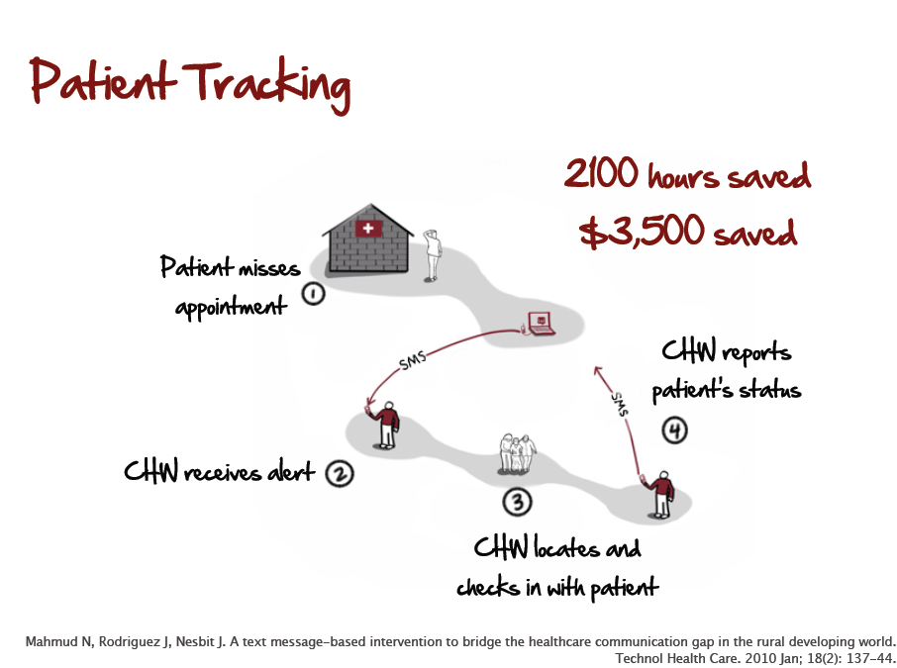

**Why not SMS?**

SMS can be a powerful, widespread, low-cost, accessible technology, but all technologies have barriers to access and entry. It is important to recognize these barriers, mitigate them, and work to ensure that those excluded from using SMS can reach you in other ways.

**Common barriers for individuals include:**

**Literacy:** If you don’t read, SMS can be difficult to use. There are varying levels of literacy, beyond the ability to read in a conventional sense.

* *Proximate literacy* means people leveraging others’ reading ability to read and reply to text messages. This is a common strategy for older people.Even the most rural communities may have one person who reads.
* *Functional literacy* is also common - where familiar SMS formats, for example, from mobile money providers, are interpreted rather than read.

While there are workarounds, the effectiveness of some SMS projects can be reduced where people are not literate. The likelihood that they use SMS is lower, and they may lack sufficient *technological literacy* to find SMS on the mobile handset. This is why context assessments matter. See the [PEPL case study](http://www.frontlinesms.com/2013/07/11/strengthening-participatory-organization-uses-frontlinesms-in-pakistan-to-improve-service-delivery-after-floods/) for an example of a project that dealt successfully with low literacy by using number codes to get feedback from people.

**Resources**: SMS is a lowest-common-denominator technology, works on every handset, and is relatively cheap. Although barriers to entry are lower than with any other type of digital data, access to a handset, paying to charge it and buying airtime can still consume a significant portion of daily disposable income (see [this blog post](http://www.kiwanja.net/blog/2011/05/the-dollar-a-week-mobile-challenge/) for a consideration of managing on $1 per week airtime). In some communities, charging a phone may cost more time and money than buying airtime, requiring a trip and payment to a charging center. There may be other considerations out of a person’s control. For example, following an emergency, power may not be reliable.

**Gender and other individual barriers:** It’s hard to make basic statements about women’s use of technology in the developing world with great confidence. What is clear, is that women will experience all the same barriers to mobile phone access and using SMS as men, but often to a greater degree: they are less likely to be literate; may not have free or unobserved access to handsets; lack access to handsets and electricity; have lower incomes; and experience difficulty traveling to get a signal or to charge handsets in rural areas. Finally, cultural factors may inhibit SMS use, where gender roles dictate that using technology is not appropriate or necessary for women or girls.

Disability and infirmity may make SMS hard to read and access, so they may not be appropriate for people living with disabilities, or for older people, who may in any case be less aware of, or likely to adopt, new technologies.

**Coverage Infrastructure:** As with any telecommunications service, the possibilities are only as good as the infrastructure and coverage. FrontlineSMS works anywhere that there is a GSM signal and retains limited functionality without any connection. Still, the available network coverage is a critical factor in considering whether SMS is the right communications tool for the context.

**Program design considerations:**

**Context is key:** Understanding how the local community uses SMS is critical. Before embarking on an SMS project, talk to people about how and whether they already use SMS, and understand the nuances of who does and does not have effective access (see section above). SIMLab has a Context Assessment Worksheet to help you work through this. Where SMS use is inhibited by cultural and technical factors, it is far better to use communications tools that already work for the community.

**Incentivizing engagement:** People often ask us how they will get people’s numbers, but this does not necessarily come at the problem from the right viewpoint. Sending SMS to lists of numbers can be a high-cost, low-value approach. Higher-value communications can be achieved when users opt-in to services. They sign up for updates because they want them, or because of an incentive. There are many ways to incentivize engagement. For example, a radio competition for people sending SMS comments, or an airtime reward for completing a survey. Another excellent approach is to address an existing need in an accessible and efficient way. For instance, augmenting an existing ‘complaints box’ with an SMS complaints system will remove the need for people to travel to give feedback, saving them time and money. The balance of incentives is critical here, particularly where incomes are low. Asking people to spend time and phone credit to engage with you is a significant thing. People need to know that their investment will be rewarded.

**How SMS is currently perceived and used:** Some cultures regard SMS as lacking the necessary validity, professionalism, or depth to have real significance, and would not take seriously health messages or services that use them. At the other end of the scale, in some places SMS are overused and likely to be perceived as spam. You can counteract this by building a more interactive, long-term relationship with your intended recipient, establishing trust and ensuring that people value your SMS communications (including by allowing them to opt in and out, as suggested above).

**Building an effective multi-channel approach:** With the spread of smartphones and the mobile web, people have access to other communications platforms. This varies between individuals and even day-to-day, based on variations in coverage and financial security. Communicating with individuals with different needs and habits may mean providing varied options for engagement. A successful communications approach might include noticeboards, group meetings, radio, SMS and voice channels.

Additionally, there is value in looking critically at available technologies and considering the information involved with data collection and management. There may be small packets of information that could have a large impact if moved quickly, such as river level data sent via SMS. On the other hand, long-form surveys and assessment questionnaires may be more suited to GPRS data collection tools. Even here, small amounts of information could be lifted out and sent via SMS where there is no GPRS connection, to combine rich slow data with real-time SMS data. SMS should be viewed as one of the tools in your toolkit.

**Monitoring impact:** Very few agencies experimenting with mobile other than as a direct element of program delivery (e.g. health messaging to expectant mothers) effectively monitor the impact, or even the outcome, of the innovation. Contact SIMLab for sample indicators for the activities, outputs, outcomes and impact of using SMS and tech in a range of ways in an organization.

**Information Security and Data Integrity**: Frontline products operate by sending a message from the software to a modem or mobile phone, over the network, to the person receiving the message (or vice versa). Messages could be intercepted at three points of insecurity: the receiving phone, the network, or the laptop. Normal staff security measures and checks (keeping the FrontlineSMS setup in a secure place, for example) should suffice to protect the laptop and sending device from malicious intent. Bear in mind that the network itself may not be secure or that the message could be intercepted on the receiving phone. Implementers should structure communications to minimize exchanging sensitive information where these are concerns. If information is being gathered remotely, it will be important to institute controls and checks to ensure that the accuracy of the data is tested. For more guidance, see our [Data Integrity guide](http://www.frontlinesms.com/wp-content/uploads/2011/08/frontlinesms_userguide.pdf).

**Legality**: Some states have regulated sending bulk SMS, and may require you to get a license and conform to certain rules in order to send SMS to many people, even using devices such as modems. You should check the legal requirements in your country of operation. Be aware that the terms and conditions of some SIM card plans preclude ‘machine to machine’ SMS, i.e. using a modem with a computer to send SMS. If this kind of activity is suspected, the service provider may disconnect the number.

**Cost of SMS**: SMS cost is a significant consideration for organizations designing an SMS-based system. It is rare to find operators who will lower prices, even for non-profits. Cost of SMS can be mitigated or offset by using SMS to replace more costly or inefficient forms of communication. Traditional mail may seem cheaper than SMS at first glance, but if you factor in the printing supplies, staff preparation time, envelopes, postage, the delivery delay, and the uncertainty of receipt, SMS is often more cost-efficient. SMS could also improve the quality or volume of interactions, reducing cost and improving services by speeding up communication or increasing stakeholder feedback. You may be able to defray costs by developing partnerships with relevant service providers, advertisers, donor mobile networks, or partners with larger communications budgets. Another option is to charge subscription fees for services that represent a financial benefit to users, like providing market price information. Sustainability and cost considerations help you to design more effective projects, forcing you to focus on getting the most value you can out of every SMS.

**Factors to consider for organizations**

**Bureaucracy (Buy-In)**: In many cases, early Frontline adopters have to convince other members of their organization about the potential impact of mobile integration. One key element of successful program design is a clear definition of success. In instances where managerial buy-in is required, implementers should design pilots to improve the organization’s performance using the indicators that stakeholders prioritize. Developing case studies from well-documented pilots, and collecting and publishing impact and robust performance data are key ways to help build buy-in for your project.

**Staff Resources:** Staff may be concerned that adopting FrontlineSMS/Cloud will create more work for them and require significant time, a limited resource in most organizations. The amount of staff time consumed by using FrontlineSMS/Cloud is a direct reflection of how effectively it’s integrated into an organization’s communication workflow. FrontlineSMS/Cloud is more likely to save organizations time by automating otherwise lengthy processes.

**Change management:** Organizations need to recognize that they are revolutionizing the way they manage data or interactions, and plan accordingly. Whether they are professionalizing existing SMS communication, requiring different behaviors of staff, or adding a mobile channel to a feedback mechanism, they are changing the way things are done. Small-scale, well-documented pilots, giving staff time to adapt, and allowing sufficient resources to cope with additional communication and data are all important considerations.

**SIMLab Resources**

* [How to geolocate an SMS](http://frontlinesms.ning.com/forum/topics/geolocating-sms)
* [Data Integrity Guide](http://www.frontlinesms.com/impact-of-frontline/guides-tools-and-case-studies/)
* Context Assessment Checklist- shortened version available [here](https://coursessimlab.typeform.com/to/ekCyFx)